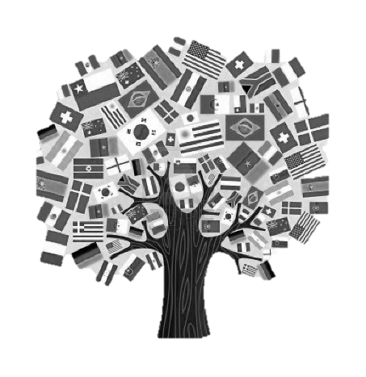
Horne Streeet School
International Cultural Festival
Share your heritage as we celebrate and learn about the diverse cultures of our students and families at the HSS International Cultural Festival!

Wednesday April 3rd, 2019 from 6-7:30 PM
YES! My family would like to participate.
We will represent our cultural/heritage of:
____________________________________________________________________________
(For example: (India, Poland, France, Mexico…)

During the evening of April 3rd stations will be set up around the gym. Each family, representing a different culture, will have a station to set up a cultural display and traditional food (if applicable) for others to observe and share. The gym will also be set-up for dances, musical performances, skits and more…

We would like to create a playlist of a variety of music from different cultures/heritages to play as background music during the evening. To share music for performances and playlist, please send as an MP3 file to Mrs. Drysdale: r.drysdale@dover.k12.nh.us.

Ideas of what you can do at your station:
- Speak (and then translate) in your traditional language
- Teach & play traditional games
- Show traditional clothes
- Learn to write letters of the alphabet in a different language
- Perform a traditional dance
- Tell a short story in your language
- Show and play with toys from another country
- Your own ideas are welcome! _______________________________________

Please return to Mrs. Smart or Ms. Dunn by Wednesday, March 20, 2019

Name ___________________________________________________________________
E-mail ___________________________________________________________________
Best phone number to reach me: _____________________________________________
I can make traditional food for my station YES NO
I am available to read/share during the school day YES NO
I am available for the evening International Cultural Festival YES NO

Equipment needed: ___________________________________________________________
Questions? Please e-mail Ms. Dunn at m.dunn@dover.k12.nh.us or Mrs. Smart at l.smart@dover.k12.nh.us

